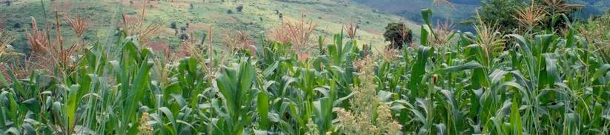
Press Release

Optimising the use of pesticidal plants in Zimbabwe

A new international agricultural research project has recently started work in Zimbabwe. The Southern African Pesticidal Plants Project, or the SAPP project for short, is led and coordinated by scientists at the Natural Resources Institute of the University of Greenwich in the UK and involves organisations from Zambia, Malawi and Zimbabwe as well as the world-famous Royal Botanic Gardens at Kew.
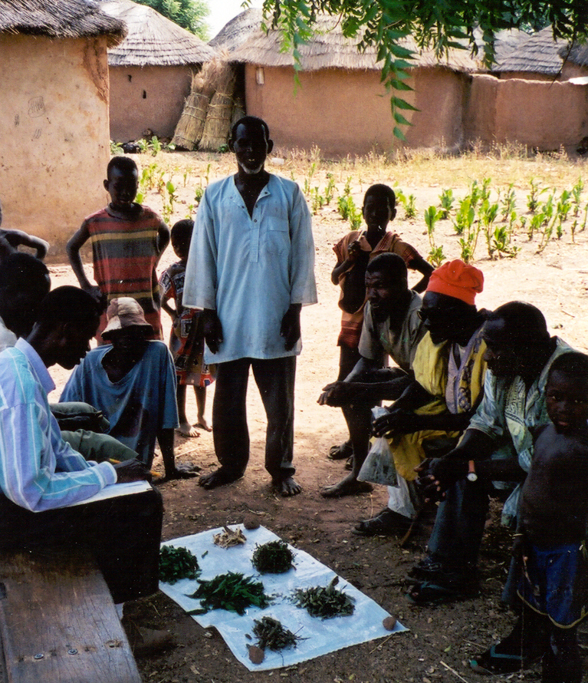Farmers consider many factors when choosing pesticidal plants. Availability may be as important as efficacy as many natural habitats become degraded.
Plants with pesticidal properties can provide poor African farmers with effective and low-cost insect pest management methods for vegetable production, treating stored grain and protecting livestock from ticks and mites. Pesticidal plants have been used by African farmers for generations, particularly by small-scale farmers who may not be able to afford to buy commercial synthetic insecticides. Although commercial insecticides are usually effective, there are constraints to their use. In addition to high prices, their availability may be limited in rural areas, and their effectiveness may be reduced by adulterated or inappropriately applied products. Surveys with rural farmers have highlighted these problems, and along with health and safety fears, lead to many farmers avoiding commercial products.
Plant materials are perceived as safe alternatives to synthetic pesticides, and farmers recognise that pesticidal plants are a known quantity that cannot be adulterated. However, their use can have associated health risks. For example, the plant Tephrosia vogelii (fish-poison bean) is traditionally used as a fish poison and contains a compound called rotenone which has toxic effects in humans. However, Tephrosia is actively promoted for protecting stored grain from insect attack through many extension programmes in southern Africa. This seems, at best, ill-advised as the toxin may be ingested with the food grain and so may present health risks to users and consumers. One of the main activities of the SAPP project will be to investigate the safety of using pesticidal plants, ensuring that safe methods for their use are sustainably promoted.
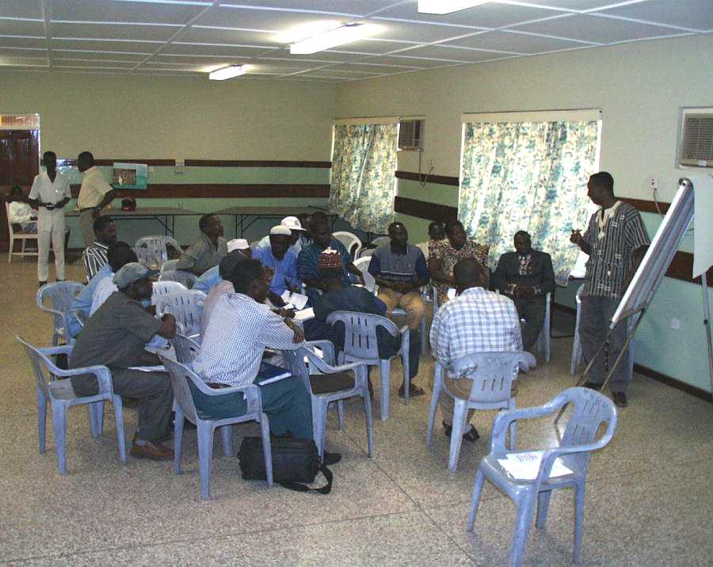
NGO and government agricultural extension staff learning how to safely and sustainably promote pesticidal plants.
Over-harvesting of some plant species threatens the diversity of local habitats too. So the SAPP project will study how the plants work, develop improved application, harvesting and cultivation techniques. Their cultivation will generate additional cash for poor farmers, while markets that are developed for these plants will promote conservation across the region by reducing the pressure of wild plant collecting.

The SAPP project has been getting started with an inception workshop at Kew Gardens in January 2007. Scientists from Malawi, Zimbabwe and Zambia were at Kew to discuss and plan activities with UK colleagues. Professor David Hall of NRI said that Stephen Nyirenda from Department of Agriculture, Malawi “had been worried about the misuse of poisonous plants for pest management in Malawi for ages, and wanted to do something about it”. SAPP project actions over the next three years are financed by the EU through the SADC’s agricultural research and training initiative.
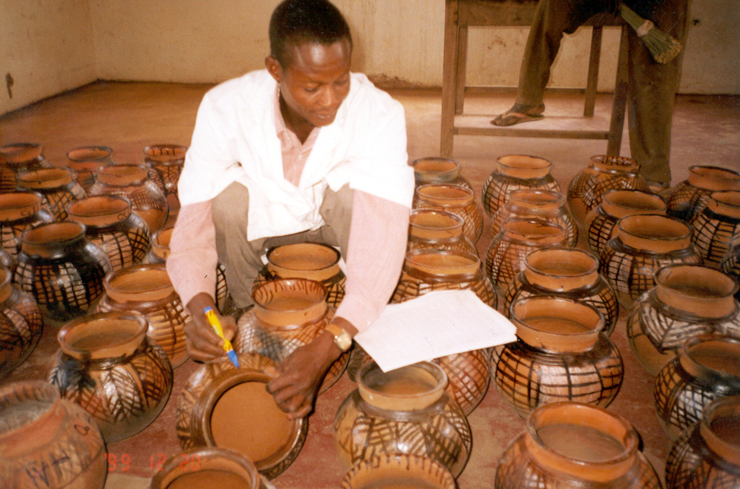Setting up field and farm trials to evaluate pesticidal plants under ‘semi-natural’ conditions using traditional pots commonly used for storing cowpeas.
Further information about the project can be found through the website http://www.nri.org/sapp, or contact:
Dr Brighton Mvumi, University of Zimbabwe, Tel 04 303211 x1439;
Dr Phosiso Sola, SAFIRE, Tel 04 736235/47;
Dr Phil Stevenson (project leader) Email p.c.stevenson@gre.ac.uk

